Ocean Winds selects Siemens Gamesa as the offshore wind turbine supplier for the BC-Wind project in Poland

- Ocean Winds has entered into a key agreement with Siemens Gamesa for the supply of SG 14-236 wind turbines and service maintenance, marking a significant step towards the realization of the offshore BC-Wind project in the Polish Baltic Sea.
- The implementation of these advanced technological solutions will be essential in generating zero-emission energy, addressing the energy needs of approximately 488,000 households in Poland, and facilitating the national energy transition.

Warsaw, July 29th, 2025: Ocean Winds, an international company dedicated to offshore wind energy and created as a 50-50 joint venture in 2020 by EDP Renewables and ENGIE, has signed contracts for the supply of wind turbines and a service maintenance agreement for its BC-Wind project. The agreement is conditional and subject to Notice to Proceed (NtP) from Ocean Winds. This key project, part of Phase I of offshore development in the Polish Baltic Sea, will produce zero-emission energy capable of supplying electricity to approximately 488,000 households in Poland. We expect the first power to flow from the BC-Wind wind farm in 2028.

The agreement covers the delivery of 26 wind turbines, each with a nominal capacity of 14 MW and
a Power Boost feature capable of increasing capacity to 15 MW. Installation and commissioning of these turbines are planned for the 2028. These turbines received IECRE type certification last summer, confirming their compliance with international quality and safety standards.

The marshalling harbour for the project will be Terminal T5 in the Port of Gdańsk in Poland, which will serve as the logistics base for pre-assembly and load-out operations. Cadeler will be responsible for the transportation and installation of the turbines, utilizing its O-class vessels.

“We are pleased to announce this significant milestone for our project in Poland, marking a key contribution to the country’s energy transition. This project not only underscores our commitment to renewable energy but also affirm that the Baltic Sea is a crucial market for us. By leveraging our extensive experience and advanced technology, we are set to deliver substantial environmental and economic benefits - supporting the ongoing energy transition in Poland.”
Kacper Kostrzewa, Managing Director for Poland, Ocean Winds

"After a thorough assessment of macroeconomic factors and detailed calculations, we have decided to choose Siemens Gamesa. This decision is grounded in their proven efficiency and the technological evolution from the model we successfully deployed at the Moray West project in the UK. Building on that hands-on experience, we are confident that this solution will deliver strong performance for our project in Poland. The agreement also includes service and maintenance, ensuring reliability and optimal performance throughout the project's operational life."
Pete Geddes, Project Director for BC-Wind, Ocean Winds

“The Baltic Sea is an ideal location for offshore wind energy. Thanks to our long-standing partnership with Ocean Winds, we are well-positioned to harness the potential of wind energy in Polish waters. As the project progresses—as we fully expect—we are prepared to advance offshore wind energy further with our 14-megawatt turbines. This will contribute to establishing wind-generated electricity as a strong and reliable energy resource in Europe for the long term.”
Marc Becker, Senior Vice President of Siemens Gamesa for Offshore

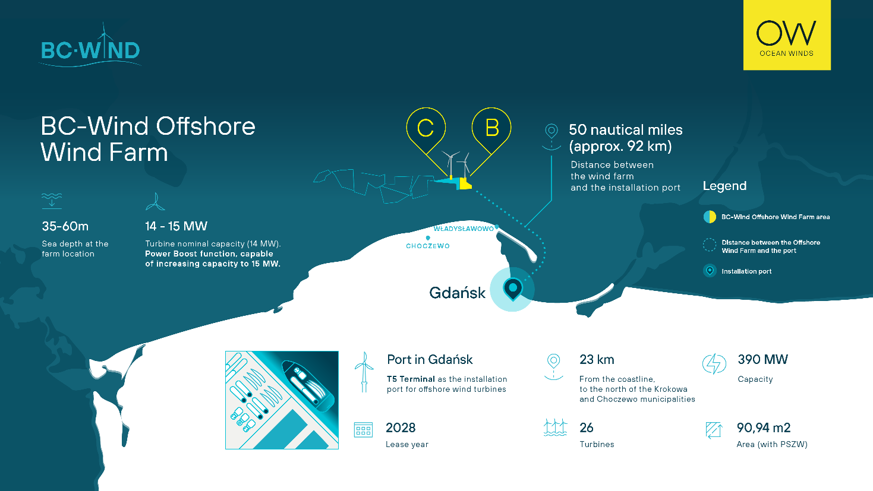
Project BC-Wind in Poland, graphic: Ocean Winds

BC-Wind is an offshore wind farm project located approximately 23 kilometers north of the shore,
off the coast of the Krokowa and Choczewo municipalities in the Pomeranian Voivodeship. The project aims to achieve a planned capacity of up to 390 MW, with a total farm area of 90.94 km². The implementation of this project represents a significant advancement in increasing the share of renewable energy sources in Poland’s energy mix and enhancing the country's energy security.

The project currently holds an environmental decision for both the offshore and onshore components, as well as rights to a Contract for Difference (CfD). It is now at an advanced stage of development, with efforts focused on selecting the remaining key suppliers. The selection of the turbine supplier represents a major milestone in the project's progress, bringing it closer to contract finalization and paving the way for a Final Investment Decision (FID) to be made within this year.

– The end –

About Ocean Winds
Ocean Winds (OW) is an international company operating in the field of offshore wind energy, established as a joint venture between EDP Renewables and ENGIE, with a 50:50 partnership. We firmly believe that offshore wind energy is a fundamental element of global energy trans-formation, which is why we develop, finance, build, and operate offshore wind farm projects worldwide.

When EDP Renewables and ENGIE merged their offshore energy assets and programs in 2019 to create Ocean Winds, the company had a combined capacity of 1.5 GW under construction and an additional 4.0 GW in development. OW is rapidly expanding its portfolio and is currently striving to achieve a target capacity of 5-7 GW by 2025, including operational projects, projects under construction, and those in advanced stages of development, as well as 5-10 GW within projects undergoing advanced development activities. Currently, OW's gross energy capacity, including operational, under construction, and advanced-stage development projects, has reached around 19 GW.
www.oceanwinds.com
www.bc-wind.pl

Media contact:

Ocean Winds | Jose Miguel Mesa | josemiguel.mesa@oceanwinds.com
BC-Wind | Aleksandra Jampolska | Aleksandra.jampolska@oceanwinds.com

